Hands on with Querying using Regex Expression

In order to perform following queries use a collection products with the following documents:

{ "_id" : 100, "sku" : "abc123", "description" : "Single line description." }  
{ "_id" : 101, "sku" : "abc789", "description" : "First line\nSecond line" }  
{ "_id" : 102, "sku" : "xyz456", "description" : "Many spaces before     line" }  
{ "_id" : 103, "sku" : "XYZ789", "description" : "Multiple\nline description" }

1. find the documents whose description starts with "M".

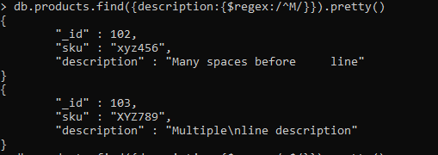

2. find the documents whose description end with "n"

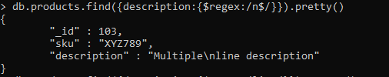

3. find the documents whose description contains "line" word"

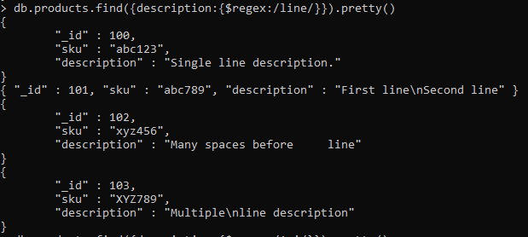

4. find the documents whose description contains second character "i".

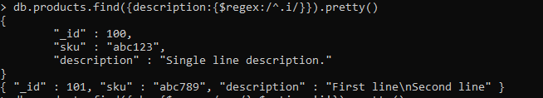

5. find the documents where "sku" fields contains "xyz", ignore the case sensitivity.

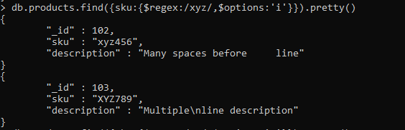

6. find the documents where any line from the description starts with 'S.

